FOR IMMEDIATE RELEASE
March 10, 2026

CONTACT: Erin Zeigler
CELL: 629-277-2458

TRAFFIC ADVISORY

I-840 Milling and Paving Delayed Due to Weather
Nashville, Tenn. – Forecasted rain and low temperatures have prompted the Tennessee Department of Transportation (TDOT) to delay previously scheduled lane closures on Interstate 840 in Williamson County.
Beginning Monday, March 16, until at least Sunday, March 22, crews with Volunteer Paving will begin intermittent closures of lanes and ramps on I-840 from near Lewisburg Pike (US 431) to the bridge over Harpeth School Road in Thompson’s Station (red line on map below). Nighttime closures will be conducted on weekdays from 8 p.m. to 5 a.m. to mill the roadway, while daytime closures from as early as 7 a.m. to as late as 6 p.m. will be conducted on weekends for paving. Paving cannot be completed at night due to low temperatures during this time of year. For the materials to properly cure and achieve long-term durability, consistently warmer outside temperatures are required.
Follow @ErinTDOT and @myTDOT on X for any updates on timing.
These closures are necessary for crews to begin milling and making spot repairs on I-840 to prepare for a resurfacing project. The full resurfacing on I-840 from just west of State Route 6 (US 31/Columbia Pike) to near Arno Road is in TDOT’s 3-Year Pavement Plan for this year (blue line on map). Full project construction is tentatively scheduled to begin this July.
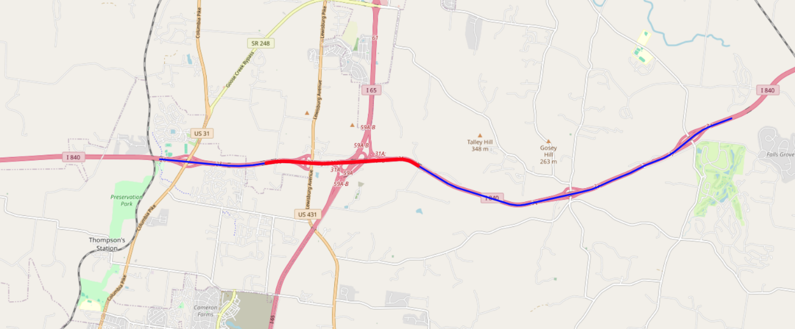
All work is weather-dependent. As always, drivers are reminded to allow additional time, slow down, and move over when traveling through a work zone. The Move Over Law was passed in 2006. The penalty for violating the law in Tennessee includes the possibility of up to 30 days in jail and a maximum fine of $500.
Motorists can report potholes to TDOT by calling the TDOTFIX Hotline at 833-TDOTFIX or using this online form: TDOT Maintenance Request. The TDOT SmartWay Map (https://smartway.tn.gov) provides the latest traffic updates on construction activity. Travelers can also call 511 for travel information.

